
COMSATS University Islamabad,
Abbottabad Campus

SOFTWARE DESIGN DESCRIPTION
(SDD DOCUMENT)
for
Home Ease
Version 1.0
By
Hashir Hamid — CIIT/FA22-BSE-139/ATD
Aman Ullah Khan — CIIT/FA22-BSE-074/ATD
Umar Saeed — CIIT/FA22-BCS-041/ATD
Supervisor
Sumair Khan

Bachelor of Science in Software Engineering (2023-2027)

Table of Contents
1. Introduction 6
2.1. Purpose 6
2.2. Scope 6
2. Design Methodology and Software Process Model 7
2.1. Design Methodology 7
2.2. Software Process Model 8
3. System Overview 8
3.1. High-Level Functionality 8
3.2. Architectural Design 10
3.3. Architecture Diagram 11
3.4. Process Flow / Representation 12
4. Design Models 13
4.1. Class Diagram 13
4.2. Sequence Diagram 14
4.3. State Transition Model 15
5. Data Design 16
5.1. ER Diagram 16
5.2. Entity Descriptions 17
5.3. Data Dictionary 21
6. Algorithm and Implementation 22
7. Software Requirements Traceability Matrix 25
8. Human Interface Design 28
8.1 Mobile App 28
9. Appendix A: Glossary of Terms & Acronyms 29
9.1. A.1 Glossary of Terms & Acronyms 29

List of Figures
Fig 3.1 Architecture Diagram 11
Fig 3.2 Process Flow Diagram 12
Fig 4.1 Class Diagram 13
Fig 4.2 Sequence Diagram 14
Fig 4.3 State Transition Diagram 15
Fig 5.1 ER Diagram 16
Fig 8.1 Mobile Dashboard 28
Fig 8.2 Mobile Login 28
Fig 8.3 Worker Dashboard 28
Fig 8.4 Booking Screen 28

Revision History
Name | Date | Reason for changes | Version

Application Evaluation History

Comments (by committee)  *include the ones given at scope time both in doc and presentation | Action Taken

Supervised by
Sumair Khan
Signature_____________

Introduction
This Software Design Description document describes the design of HomeEase, a Flutter mobile application for household and worker users supported by a lightweight React/Vite admin web dashboard. The document translates the SRS requirements into a concrete design plan covering system architecture, module decomposition, data entities, algorithms, traceability, and user interface behavior.
The design covers these modules:
- Authentication and role management.
- Household user management.
- Worker profile management.
- Worker verification.
- Service category and pricing.
- Search and matching.
- Booking and availability management.
- Basic service agreement management.
- Manual payment tracking through EasyPaisa/JazzCash receipt upload.
- Dispute resolution and issue handling.
- Rating and review.
- Notification and communication.
- Admin web dashboard management.

Purpose
The purpose of this Software Design Description document is to explain how the HomeEase requirements will be transformed into a working software design. It documents the architecture, design methodology, major modules, database entities, algorithms, traceability, and user interface behavior.

Scope
This SDD covers the design of the Flutter mobile application for household and worker users, the React/Vite admin dashboard, and the Supabase/PostgreSQL backend design. It includes authentication, role-based navigation, worker profiles, search and matching, booking, service agreement generation, manual payment receipt tracking, dispute resolution, reviews, notifications, verification, and admin monitoring.
This does not design direct payment gateway integration, payroll, government database verification, advanced analytics, full chat, or live GPS matching. These items remain outside the initial implementation scope or future enhancements.

Design Methodology and Software Process Model

Design Methodology
HomeEase follows a modular object-oriented design approach. The Flutter mobile app is divided into app flow, screens, reusable widgets, theme, models, and data/service layers. The admin dashboard will be divided into pages, components, and Supabase service functions.
Planned Flutter structure:
- ‘app‘: application entry widget and screen flow.
- ‘screens‘: mobile UI screens such as splash, login, signup, household search, worker list, worker detail, booking request, service agreement, payment receipt upload, dispute form, and worker dashboard.
- ‘widgets‘: reusable UI components such as cards, buttons, avatars, chips, and scaffold layout.
- ‘theme‘: shared colors, typography, input styling, and app theme.
- ‘models‘: data objects such as worker profile.
- ‘data‘: temporary sample data used before backend integration.
Planned backend/service structure:
- Authentication service.
- User/profile service.
- Worker search service.
- Booking service.
- Service agreement service.
- Payment tracking service.
- Dispute resolution service.
- Review service.
- Notification service.
- Admin dashboard service.
This structure keeps each responsibility separate and makes the project easier to extend from mockup UI to a working Supabase-backed system.

Software Process Model
The project follows Agile Software Development Methodology.
Justification:
- The project can be built in iterations: UI mockups, authentication, profiles, search, bookings, service agreements, manual payment tracking, disputes, reviews, notifications, and admin dashboard.
- Supervisor and user feedback can be incorporated after each phase.
- Each module can be tested independently before full integration.

System Overview
HomeEase is a client-cloud system with two frontends:
- Flutter mobile app for household and worker users.
- React/Vite web dashboard for admin users.
Supabase/PostgreSQL will act as the shared backend for authentication, data storage, and role-based access. Supabase Storage or an equivalent storage bucket will store payment receipt images and optional dispute evidence. The first version will use city/area and service-category filtering for local worker matching. Live GPS, direct online payment gateway processing, payroll, full chat, and advanced analytics are outside the scope.

High-Level Functionality
Household users can:
- Register and log in.
- Select household role on the login screen.
- Search workers by service category and city/area.
- View worker list and worker detail screens.
- Send booking requests.
- Track booking status.
- View the generated service agreement after worker acceptance.
- Upload EasyPaisa/JazzCash payment receipt after manual payment.
- Raise disputes for booking, payment, service, or behavior issues.
- Submit ratings and reviews after service completion.
- View notifications.
Worker users can:
- Register and log in.
- Select worker role on the login screen.
- Create and manage worker profile.
- Add services, expected charges, experience, area, and availability.
- Submit profile for verification.
- View incoming booking requests.
- Accept or reject booking requests.
- View generated service agreements.
- Review uploaded payment receipts and confirm payment received.
- Raise disputes for payment or service issues.
- View ratings and notifications.
Admin users can:
- Log in through the admin web dashboard.
- View worker verification requests.
- Approve or reject worker profiles.
- View users and booking records.
- View service agreement and payment tracking records.
- Handle reported disputes/issues.
- View basic dashboard counts.

Architectural Design
HomeEase uses a layered architecture.

Presentation Layer:
  - Flutter screens and widgets for household/worker users.
  - React/Vite pages and components for admin users.

Application/State Layer:
  - Screen flow, form validation, selected role, selected worker, selected service filters, booking UI state, agreement display state, payment receipt state, and dispute status state.

Service Layer:
  - Authentication service, profile service, search service, booking service, agreement service, payment tracking service, dispute service, review service, notification service, and admin service.

Data Layer:
  - Supabase client libraries, PostgreSQL database tables, and storage buckets for payment receipts/dispute evidence.

External Services:
  - Supabase Authentication.
  - Supabase PostgreSQL database.
  - Optional push notification service during later implementation.
  - EasyPaisa/JazzCash as external manual payment channels without direct transaction API integration in the first version.

Architecture Diagram
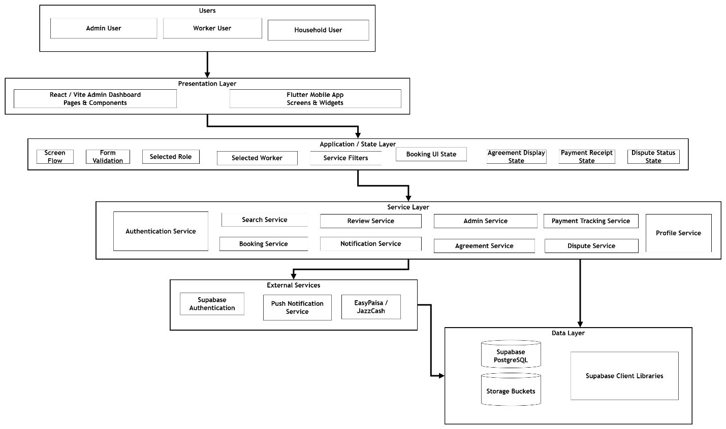
Fig 3.1 Architecture Diagram

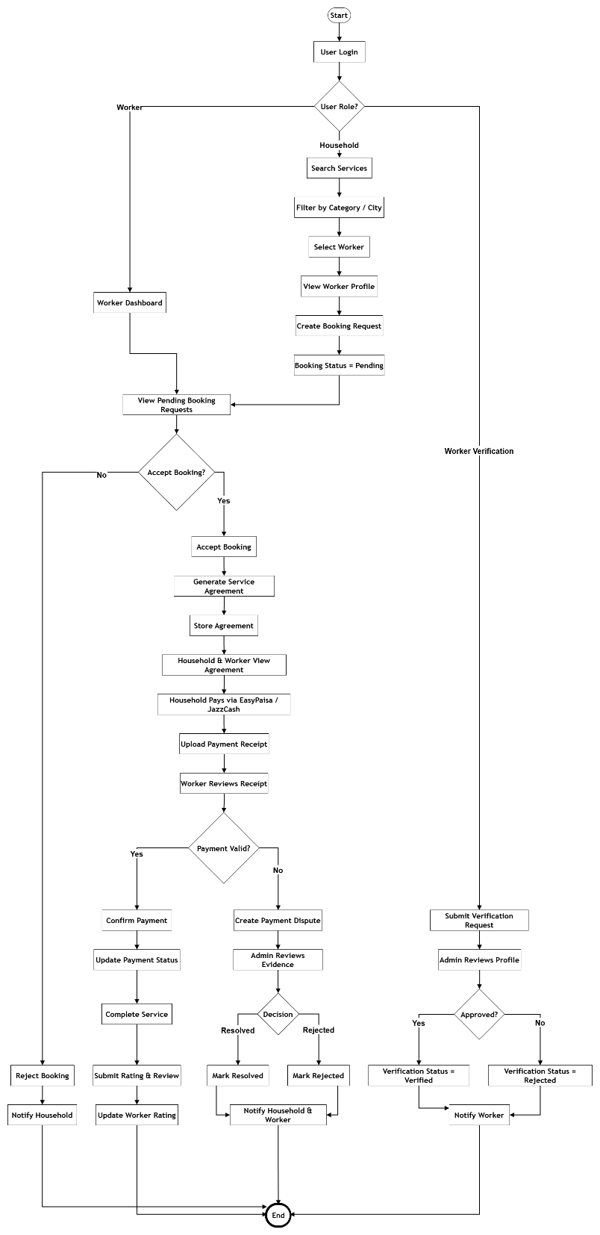
Process Flow / Representation
Fig 3.2 Process Flow Diagram

Design Models

Class Diagram
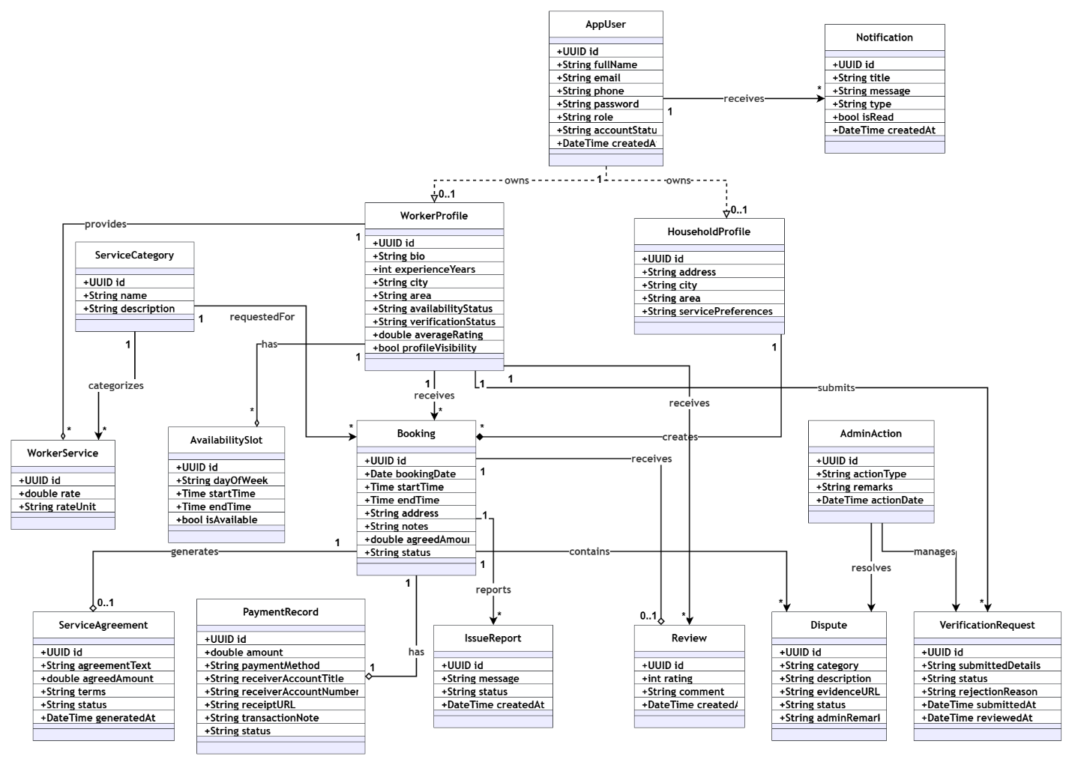
Fig 4.1 Class Diagram

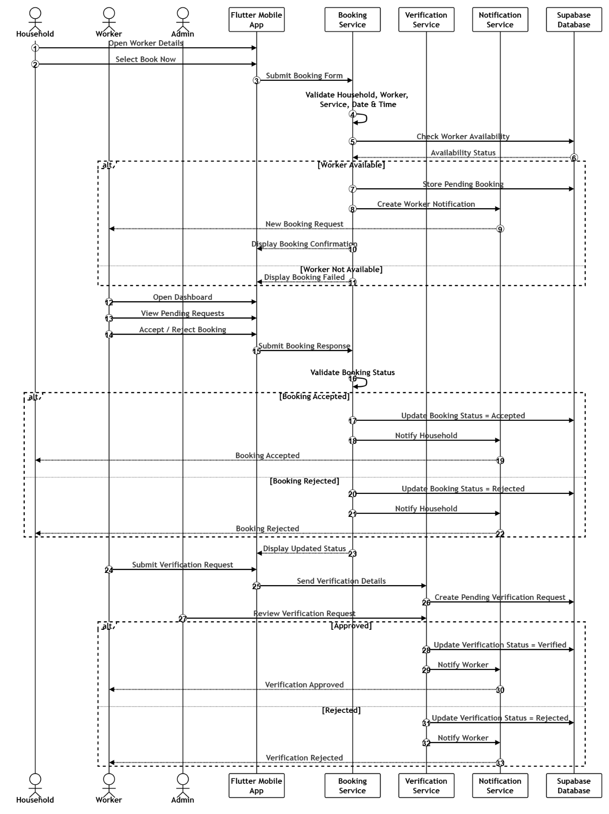
Sequence Diagram
Fig 4.2 Sequence Diagram

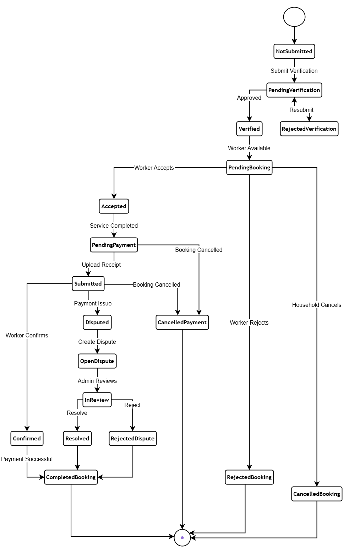
State Transition Model
Fig 4.3 State Transition Diagram

Data Design
The information domain of HomeEase consists of user data, household profile data, worker profile data, service category data, worker service/rate data, availability data, booking data, service agreement data, payment tracking data, review data, notification data, verification data, and dispute/issue report data.

ER Diagram

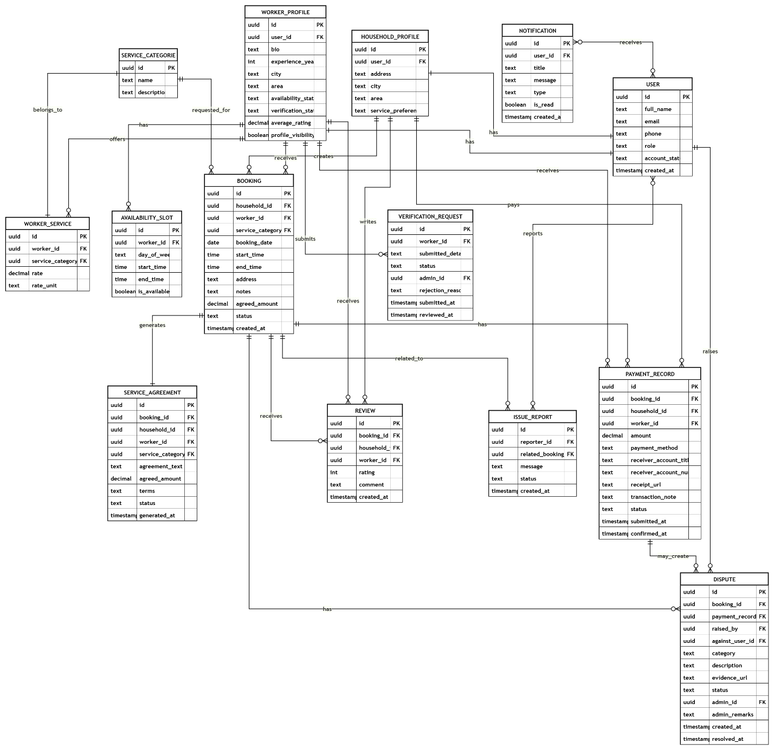
Fig 5.1 ER Diagram

Entity Descriptions

users
Stores common account data for household, worker, and admin users.
Field | Type | Description
id | uuid | Primary key / auth user id
full_name | text | User full name
email | text | User email
phone | text | User phone number
role | text | household, worker, or admin
account_status | text | active, blocked, pending
created_at | timestamp | Account creation time

household_profiles
Stores household-specific profile details.
Field | Type | Description
id | uuid | Primary key
user_id | uuid | Linked user id
address | text | Household address
city | text | City
area | text | Local area
service_preferences | text/json | Preferred service categories

worker_profiles
Stores worker profile information.
Field | Type | Description
id | uuid | Primary key
user_id | uuid | Linked user id
bio | text | Worker profile description
experience_years | integer | Work experience
city | text | Worker city
area | text | Worker area
availability_status | text | available or unavailable
verification_status | text | not_submitted, pending, verified, rejected
average_rating | decimal | Worker average rating
profile_visibility | boolean | Whether profile appears in search

service_categories
Stores available service types.
Field | Type | Description
id | uuid | Primary key
name | text | Maid, cook, cleaner, nanny, caregiver
description | text | Service description

worker_services
Links workers with service categories and expected rates.
Field | Type | Description
id | uuid | Primary key
worker_id | uuid | Linked worker profile
service_category_id | uuid | Linked service category
rate | decimal | Worker expected charge
rate_unit | text | hourly, daily, monthly, visit

availability_slots
Stores worker availability.
Field | Type | Description
id | uuid | Primary key
worker_id | uuid | Linked worker profile
day_of_week | text | Available day
start_time | time | Slot start time
end_time | time | Slot end time
is_available | boolean | Availability flag

bookings
Stores booking requests and statuses.
Field | Type | Description
id | uuid | Primary key
household_id | uuid | Linked household profile
worker_id | uuid | Linked worker profile
service_category_id | uuid | Requested service
booking_date | date | Requested date
start_time | time | Requested start time
end_time | time | Requested end time
address | text | Service address
notes | text | Booking notes
agreed_amount | decimal | Agreed service amount
status | text | pending, accepted, rejected, cancelled, completed
created_at | timestamp | Booking creation time

service_agreements
Stores basic service agreement details generated from accepted bookings.
Field | Type | Description
id | uuid | Primary key
booking_id | uuid | Linked accepted booking
household_id | uuid | Linked household profile
worker_id | uuid | Linked worker profile
service_category_id | uuid | Agreed service category
agreement_text | text | Generated agreement summary
agreed_amount | decimal | Agreed service charge
terms | text | Basic terms/notes
status | text | active, cancelled, completed
generated_at | timestamp | Agreement generation time

payment_records
Stores manual EasyPaisa/JazzCash payment tracking records.
Field | Type | Description
id | uuid | Primary key
booking_id | uuid | Linked booking
household_id | uuid | Paying household
worker_id | uuid | Receiving worker
amount | decimal | Payment amount
payment_method | text | easypaisa, jazzcash, cash, other
receiver_account_title | text | Worker account holder name
receiver_account_number | text | Worker EasyPaisa/JazzCash number
receipt_url | text | Uploaded receipt image URL/reference
transaction_note | text | Optional household transaction note
status | text | pending, submitted, confirmed, disputed, cancelled
submitted_at | timestamp | Receipt submission time
confirmed_at | timestamp | Worker confirmation time

reviews
Stores ratings and feedback.
Field | Type | Description
id | uuid | Primary key
booking_id | uuid | Linked completed booking
household_id | uuid | Reviewer household
worker_id | uuid | Reviewed worker
rating | integer | Rating from 1 to 5
comment | text | Optional written review
created_at | timestamp | Review creation time

notifications
Stores user notifications.
Field | Type | Description
id | uuid | Primary key
user_id | uuid | Recipient
title | text | Notification title
message | text | Notification body
type | text | booking, agreement, payment, dispute, verification, review, system
is_read | boolean | Read/unread flag
created_at | timestamp | Creation time

verification_requests
Stores worker verification requests.
Field | Type | Description
id | uuid | Primary key
worker_id | uuid | Linked worker
submitted_details | text/json | Verification information
status | text | pending, approved, rejected
admin_id | uuid | Admin who reviewed
rejection_reason | text | Reason if rejected
submitted_at | timestamp | Submission time
reviewed_at | timestamp | Review time

disputes
Stores booking, payment, service, or behavior disputes raised by household or worker users.
Field | Type | Description
id | uuid | Primary key
booking_id | uuid | Related booking
payment_record_id | uuid | Optional related payment record
raised_by | uuid | User who raised dispute
against_user_id | uuid | Optional user related to dispute
category | text | booking, payment, service_quality, behavior, other
description | text | Dispute details
evidence_url | text | Optional uploaded evidence
status | text | open, in_review, resolved, rejected
admin_id | uuid | Admin handling dispute
admin_remarks | text | Resolution notes
created_at | timestamp | Creation time
resolved_at | timestamp | Resolution time

issue_reports
Stores general reported issues not covered by a formal booking/payment dispute.
Field | Type | Description
id | uuid | Primary key
reporter_id | uuid | User who reported issue
related_booking_id | uuid | Optional related booking
message | text | Report details
status | text | open, in_review, resolved, rejected
created_at | timestamp | Report creation time

Data Dictionary
Name | Type | Description
user_id | uuid | Unique authenticated user identifier
role | text | User role: household, worker, admin
worker_id | uuid | Worker profile identifier
household_id | uuid | Household profile identifier
service_category_id | uuid | Selected service category identifier
booking_id | uuid | Booking request identifier
verification_status | text | Worker verification state
booking_status | text | Booking lifecycle state
rating | integer | Numeric feedback score from 1 to 5
availability_slot | object | Worker available day/time record
service_agreement | object | Accepted-booking agreement record
payment_record | object | Manual payment tracking and receipt record
payment_status | text | Payment lifecycle state
dispute | object | Booking/payment/service issue raised for admin review
dispute_status | text | Dispute lifecycle state
notification | object | User alert record
issue_report | object | User/admin issue handling record

Algorithm and Implementation

User Registration Algorithm
Input: name, email/phone, password, selected role
Validate required fields
Check whether email/phone already exists
Create authenticated user account
Store user role in users table
If role is household, create household profile
If role is worker, create worker profile shell and open worker profile setup
Return success or validation error

Login and Role Routing Algorithm
Input: selected role, email/phone, password
Validate credentials
Retrieve authenticated user role
Compare selected role with stored role
If role is household, open household home/search screen
If role is worker, open worker dashboard
If role is admin, allow web dashboard access only
Return error if role does not match or account is inactive

Worker Search Algorithm
Input: service category, city/area, optional filters
Retrieve active worker profiles
Filter by selected service category
Filter by city and area
Filter by availability if provided
Filter or sort by verification status
Sort by rating, profile completeness, and availability
Return worker list to household user

Booking Request Algorithm
Input: household_id, worker_id, service_category_id, date, start_time, end_time, address, notes
Validate household and worker records
Validate required booking fields
Check worker availability for requested slot
Check existing accepted bookings for conflict
Create booking with pending status
Create notification for worker
Return booking confirmation to household

Booking Response Algorithm
Input: booking_id, worker_id, response
Retrieve booking
Validate booking belongs to worker
Validate booking status is pending
If response is accept:
Check latest schedule conflict
Update status to accepted
If response is reject:
Update status to rejected
Create notification for household
Return updated booking status

Rating and Review Algorithm
Input: booking_id, household_id, rating, comment
Retrieve booking
Check booking belongs to household
Check booking status is completed
Check review does not already exist
Validate rating range from 1 to 5
Create review record
Recalculate worker average rating
Return success message

Worker Verification Algorithm
Input: worker_id, verification details
Worker submits profile details
System creates pending verification request
Admin reviews submitted details
If approved:
Set verification request status to approved
Set worker verification_status to verified
If rejected:
Set verification request status to rejected
Store rejection reason
Set worker verification_status to rejected
Notify worker about decision

Service Agreement Generation Algorithm
Input: accepted booking_id
Retrieve booking, household, worker, service, amount, date/time, address, and notes
Validate booking status is accepted
Generate basic service agreement text from booking details
Create service_agreements record with active status
Make agreement visible to assigned household and worker
Notify both users that agreement is available
Return agreement confirmation

Payment Receipt Submission Algorithm
Input: booking_id, household_id, receipt image, payment method, transaction note
Retrieve booking and worker payment details
Validate booking belongs to household
Validate booking status is accepted or completed
Validate receipt image exists and file type/size is allowed
Upload receipt image to storage bucket
Create or update payment_records entry with submitted status
Notify worker about submitted payment receipt
Return payment submission confirmation

Payment Confirmation Algorithm
Input: payment_record_id, worker_id, confirmation action
Retrieve payment record and linked booking
Validate payment belongs to assigned worker
If action is confirm:
Set payment status to confirmed
Store confirmed_at timestamp
Notify household about payment confirmation
If action is dispute:
Set payment status to disputed
Create or link dispute record
Notify household and admin
Return updated payment status

Dispute Resolution Algorithm
Input: booking_id/payment_record_id, raised_by, category, description, optional evidence
Validate user is related to the booking/payment or has valid report reason
Upload optional evidence if provided
Create dispute with open status
Notify admin
Admin reviews dispute and changes status to in_review
Admin adds remarks and marks dispute as resolved or rejected
Notify household and worker about final decision
Return dispute status

Software Requirements Traceability Matrix

Table 7.1 Software Requirements Traceability Matrix
Requirement ID | Requirement Summary | Design Component | Component Items
FR-01 | User registration | Authentication module | Sign-up screen, AuthService, users table
FR-02 | User login | Authentication module | Login screen, AuthService
FR-03 | Role choice on login | Role routing module | Login role controls, app flow router
FR-04 | Role-based access | Navigation/authorization module | Household flow, worker dashboard, admin dashboard, row-level access rules
FR-05 | Household profile | Household management module | HouseholdProfile model, household_profiles table
FR-06 | Worker profile | Worker profile module | WorkerProfile model, worker_profiles table
FR-07 | Service categories | Service management module | service_categories, worker_services
FR-08 | Pricing information | Worker service module | worker_services.rate, rate_unit, booking agreed_amount
FR-09 | Availability management | Availability module | availability_slots table
FR-10 | Worker verification | Admin verification module | verification_requests, admin verification page
FR-11 | Search workers | Search and matching module | Search screen, SearchService
FR-12 | Filter workers | Search and matching module | Service chips, area filters, search query
FR-13 | View worker profile | Worker detail module | Worker detail screen
FR-14 | Create booking request | Booking module | Booking request screen, bookings table
FR-15 | Booking response | Booking module | Worker dashboard/request screen, BookingService
FR-16 | Booking status | Booking module | Booking status field and status UI
FR-17 | Service agreement | Agreement module | ServiceAgreement model, service_agreements table, agreement screen
FR-18 | Agreement access | Agreement module | Household/worker agreement screen and access control
FR-19 | Manual payment details | Payment module | Worker payment fields, payment_records receiver fields
FR-20 | Payment receipt upload | Payment module | Payment upload screen, storage bucket, payment_records.receipt_url
FR-21 | Payment confirmation | Payment module | Worker payment confirmation screen, PaymentService
FR-22 | Payment status | Payment module | payment_records.status and payment status UI
FR-23 | Dispute creation | Dispute module | Dispute form, disputes table, evidence upload
FR-24 | Dispute resolution | Admin dispute module | Admin dispute page, admin remarks, dispute status update
FR-25 | Rating and review | Review module | Review screen, reviews table
FR-26 | Notifications | Notification module | notifications table, notification screen
FR-27 | Basic communication | Booking coordination module | Booking notes, accepted-booking contact details
FR-28 | Role-based UI flow | Navigation/UI module | Household, worker, and admin dashboards
FR-29 | Admin web login | Admin dashboard auth module | Web login page, AuthService
FR-30 | Admin user management | Admin users module | Users page, users table
FR-31 | Admin booking overview | Admin bookings module | Bookings, agreements, and payments pages
FR-32 | Report/dispute handling | Admin reports/disputes module | Dispute page, issue_reports/disputes tables

Human Interface Design

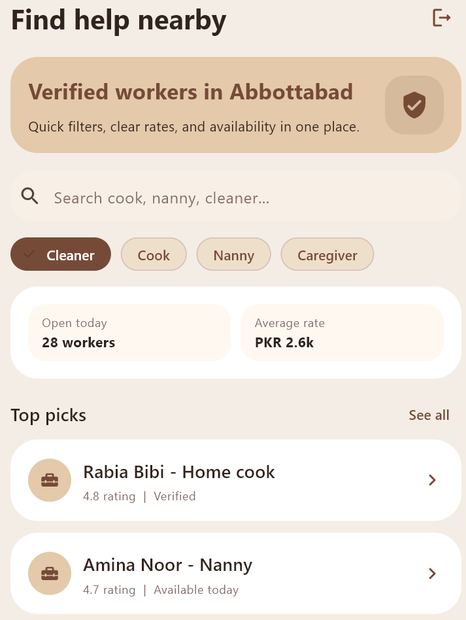
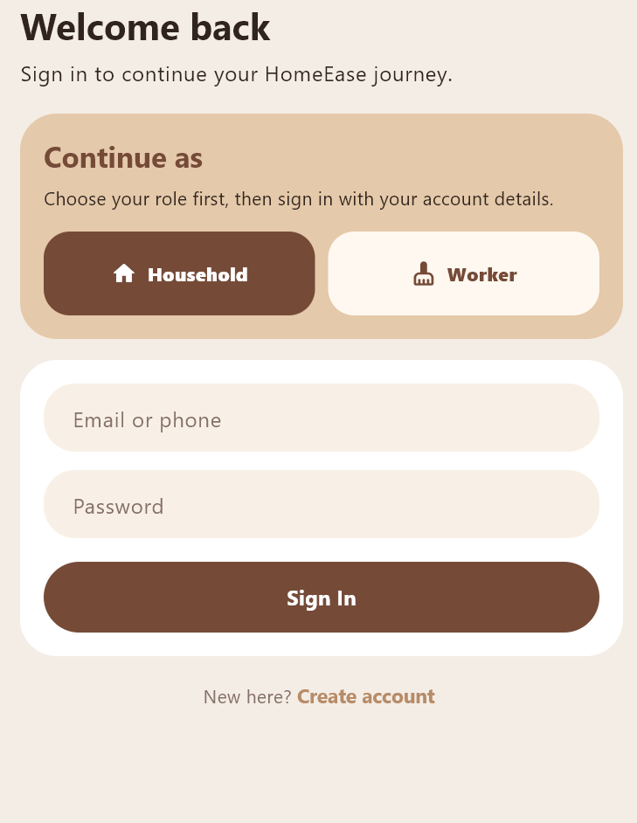
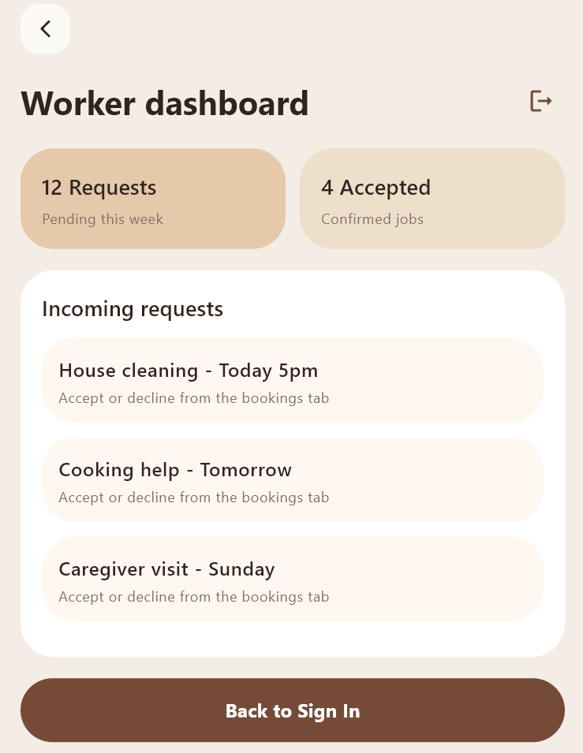
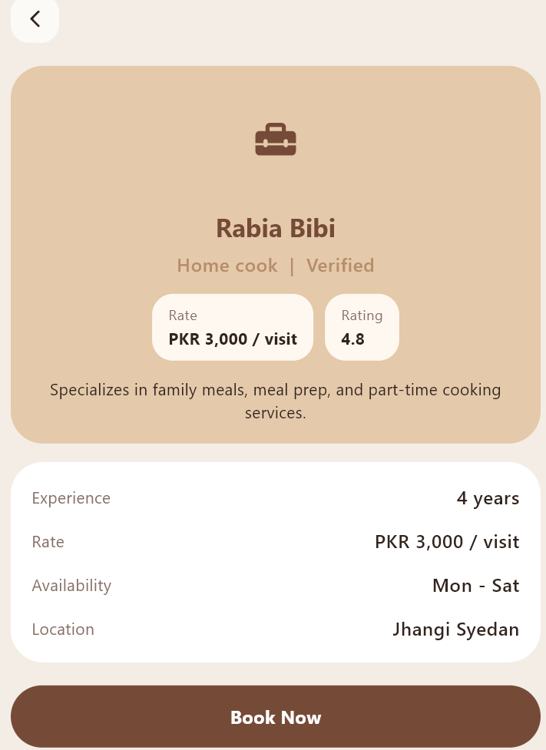
Mobile App
Fig 8.1 Mobile Dashboard
Fig 8.2 Mobile Login
Fig 8.3 Worker Dashboard
Fig 8.4 Booking Screen

Appendix A: Glossary of Terms & Acronyms
This appendix provides detailed supplementary materials for the HomeEase Software Design Description (SDD). It includes a glossary of technical terms, the complete PostgreSQL database schema (DDL) with Row-Level Security (RLS) policies, detailed algorithmic pseudo-code, and comprehensive navigation flow mapping for the mobile and web platforms.

A.1 Glossary of Terms & Acronyms
The following table defines the technical terms, acronyms, and domain-specific vocabulary used throughout the Software Design Description.
Term / Acronym | Definition | Context in HomeEase
API | Application Programming Interface; a set of protocols for building and interacting with software applications. | Used for communication between the mobile applications, web admin dashboard, and the Supabase backend.
Bcrypt | A password-hashing function based on the Blowfish cipher. | Used internally by Supabase Authentication to encrypt and securely store user passwords.
DDL | Data Definition Language; SQL statements used to define database structures, schemas, and constraints. | Represents the SQL scripts included in this appendix to initialize the HomeEase database.
Dispute | An official complaint raised by a user regarding service delivery, scheduling, or payment validity. | Enables administrators to resolve conflicts between households and workers while maintaining platform trust.
Double-Booking | A scheduling conflict in which a worker is assigned to two overlapping service appointments. | Prevented through booking validation algorithms before appointment confirmation.
EasyPaisa / JazzCash | Leading mobile wallet and branchless banking services in Pakistan. | Used by households to transfer payments directly to workers after service confirmation.
ERD | Entity-Relationship Diagram; a visual representation of database entities and their relationships. | Documents the structural relationships among HomeEase database tables.
FYP | Final Year Project; the capstone academic project completed during the undergraduate degree program. | HomeEase is being developed as an undergraduate Final Year Project at COMSATS University Islamabad.
Flutter | Google's open-source Software Development Kit (SDK) for building cross-platform mobile applications from a single codebase. | Used to develop both the Household and Worker mobile applications.
Hyper-local Search | A location-based search mechanism that matches users with nearby service providers. | Allows households to find workers based on city and locality (e.g., Abbottabad, Jinnahabad).
JWT | JSON Web Token; a compact, URL-safe token used for secure authentication and authorization. | Authenticates users and authorizes secure access to APIs, databases, and storage resources.
PostgreSQL | An advanced open-source object-relational database management system. | Serves as the primary relational database for the HomeEase backend.
RLS | Row-Level Security; a PostgreSQL security feature that restricts access to database rows based on authenticated user roles and permissions. | Protects user profiles, bookings, transaction records, and uploaded payment proofs.
RTM | Requirements Traceability Matrix; a document that maps software requirements to design components and implementation artifacts. | Ensures every requirement from the SRS is linked to corresponding modules, APIs, and database components.
SDD | Software Design Description; a document describing the system architecture, design decisions, and implementation details. | Serves as the primary technical blueprint for developing the HomeEase platform.
SRS | Software Requirements Specification; a document defining the functional and non-functional requirements of a software system. | Acts as the foundation from which the HomeEase system design is derived.
Supabase | An open-source Backend-as-a-Service (BaaS) platform providing PostgreSQL, Authentication, Storage, and automatically generated APIs. | Selected as the backend infrastructure for authentication, database management, storage, and API services.
UML | Unified Modeling Language; a standardized modeling language used to visualize, specify, and document software systems. | Used to create use case diagrams, class diagrams, sequence diagrams, activity diagrams, and state diagrams throughout the project.

